Manual Test Report

|  |  |
| --- | --- |
| **Date** | 03/03/2021 |
| **QA Owner** | Ying Wu |
| **Feature** | Log in & News |
| **Module** | Log in & News |
| **Feature Description** | 1. As a user I want to log in to the web site. 2. As a user I want to see my news. |
| **Testing Description** | For login page:   1. Scenario 1 – User access the web site for first time (when not logged in yet)    1. **Given -** the user opens web site for the first time (when not logged in yet)    2. **Then -** login screen with user name and password entries and login button is displayed 2. Scenario 2 – User login failed    1. **Given -** the user provided wrong user name and/or password    2. **When -** sign in button is clicked    3. **Then -** error markers are displayed by user name and/or password entries 3. Scenario 3 – User login succeed (credentials provided below)    1. **Given -** the user provided right user name and password    2. **When -** sign in button is clicked    3. **Then -** user is taken to the news page 4. Scenario 4 – User opens web site next time (when previously logged in)    1. **Given -** the user opens web site next time (when previously logged in)    2. **Then -** user is taken straight to the news screen   For news page:   1. Scenario 1 – News cards are loaded    1. **Given -** there is internet connection    2. **When -** the user successfully signs in to the app    3. **Then -** news cards are displayed in rows and each card contains an image, text and a view button (cards can have one or more images scrollable horizontally) 2. Scenario 2 – Failed to load news    1. **Given -** there is no internet connection    2. **When -** the user successfully signs in to the app    3. **Then -**“failed to load news” error message and a Retry button are displayed 3. Scenario 3 – News view button is clicked    1. **Given -** the news cards are successfully loaded on the screen    2. **When -** the user clicks on the view button of the card    3. **Then -** user is navigated to the image of the card |
| **Test Results** | **Partial PASS** |

* + 1. Testing information:
       1. Login credentials:
          1. User: pa55word
          2. Password: pa55word
       2. I tried to provide username and password and I found I cannot use it to login the test site, and I found provide username was not correct, the correct is “user1”

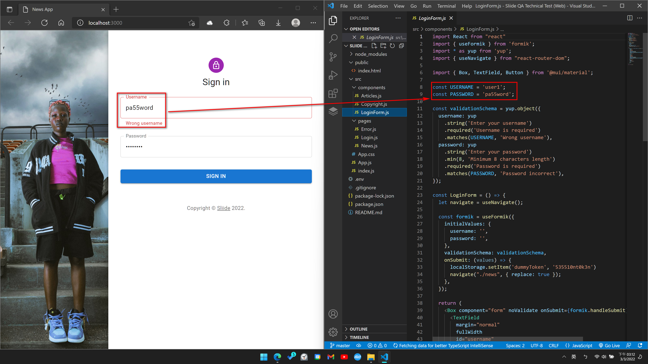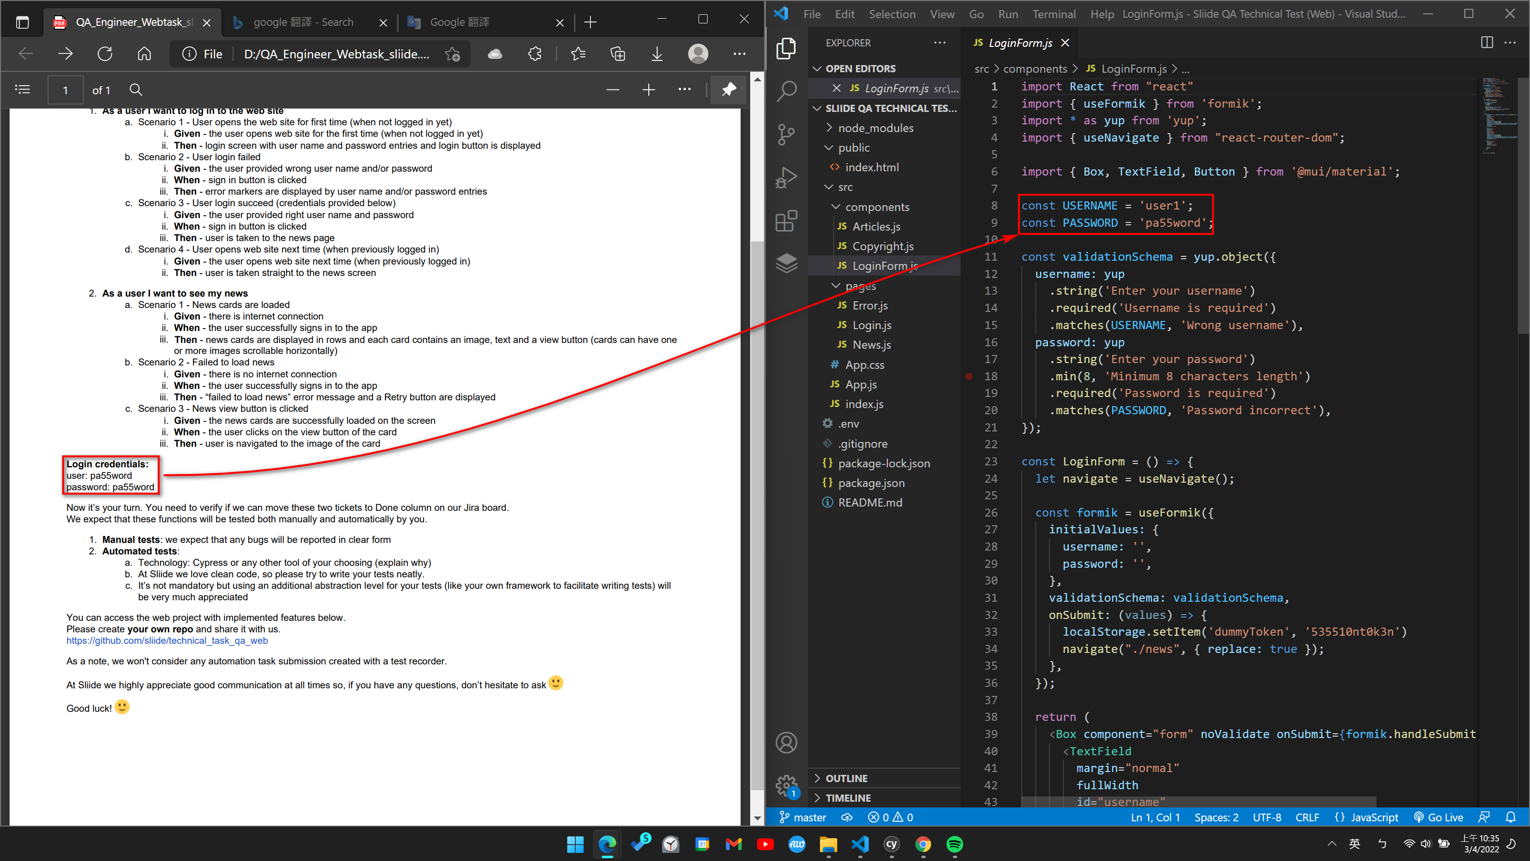

* + 1. Testing login page:
       1. Scenario 1 – User access the web site for first time (when not logged in yet)
          1. **Given -** the user opens web site for the first time (when not logged in yet)
          2. **Then -** login screen with user name and password entries and login button is displayed

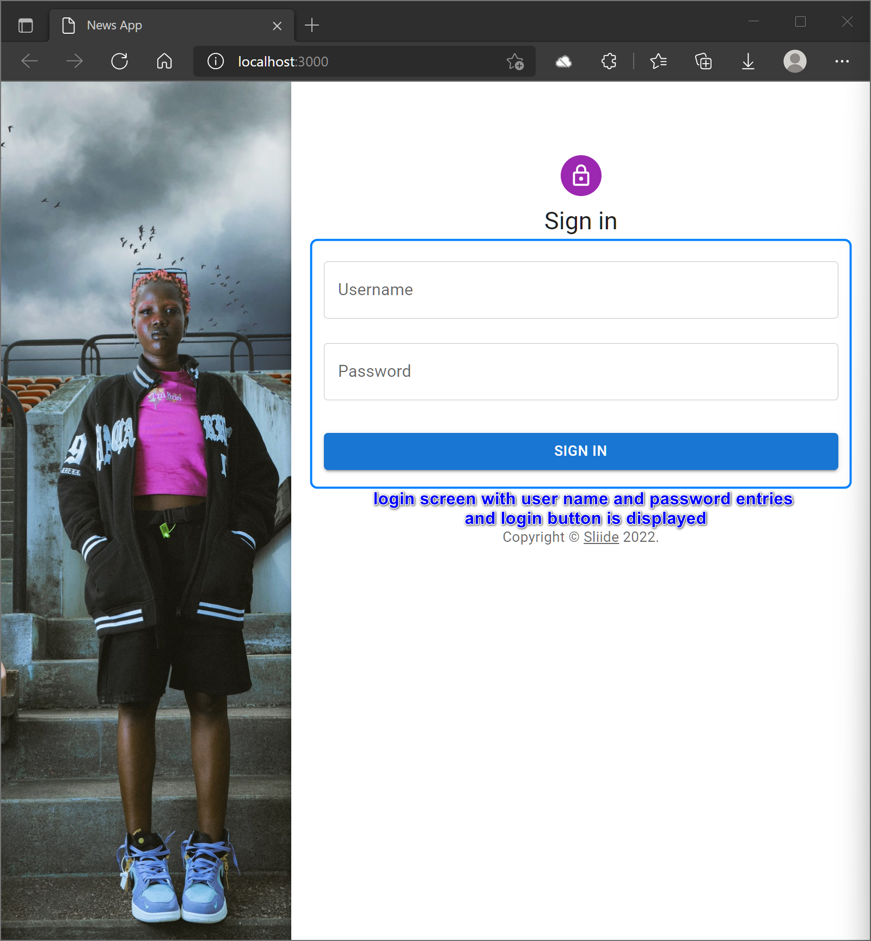

* + - 1. Scenario 2 – User login failed
         1. **Given -** the user provided wrong user name and/or password

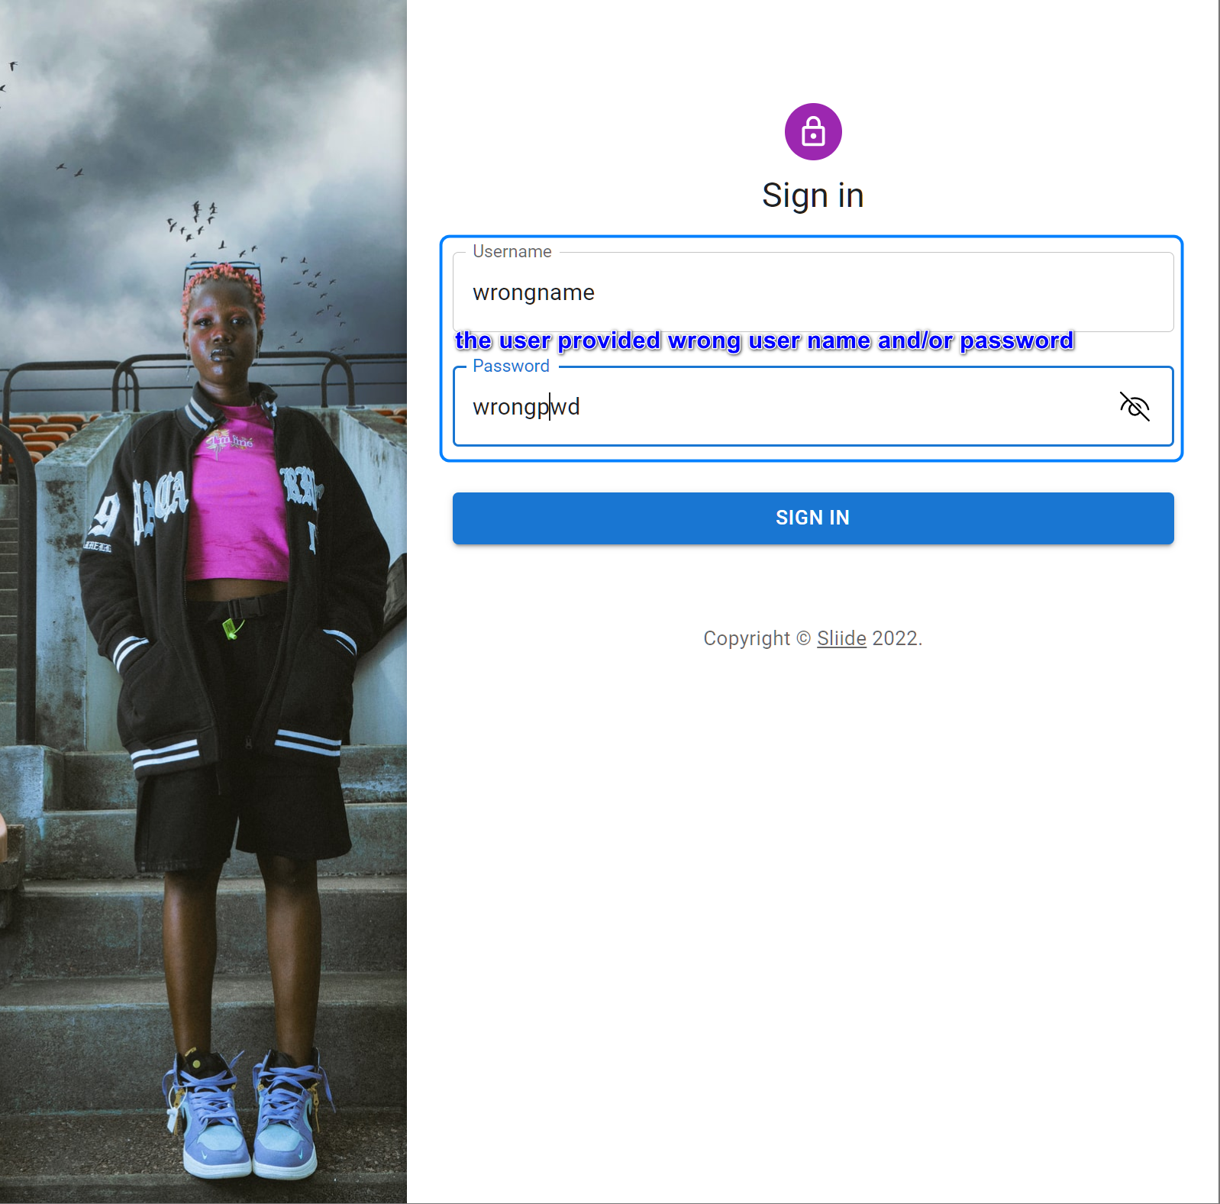

* + - * 1. **When -** sign in button is clicked

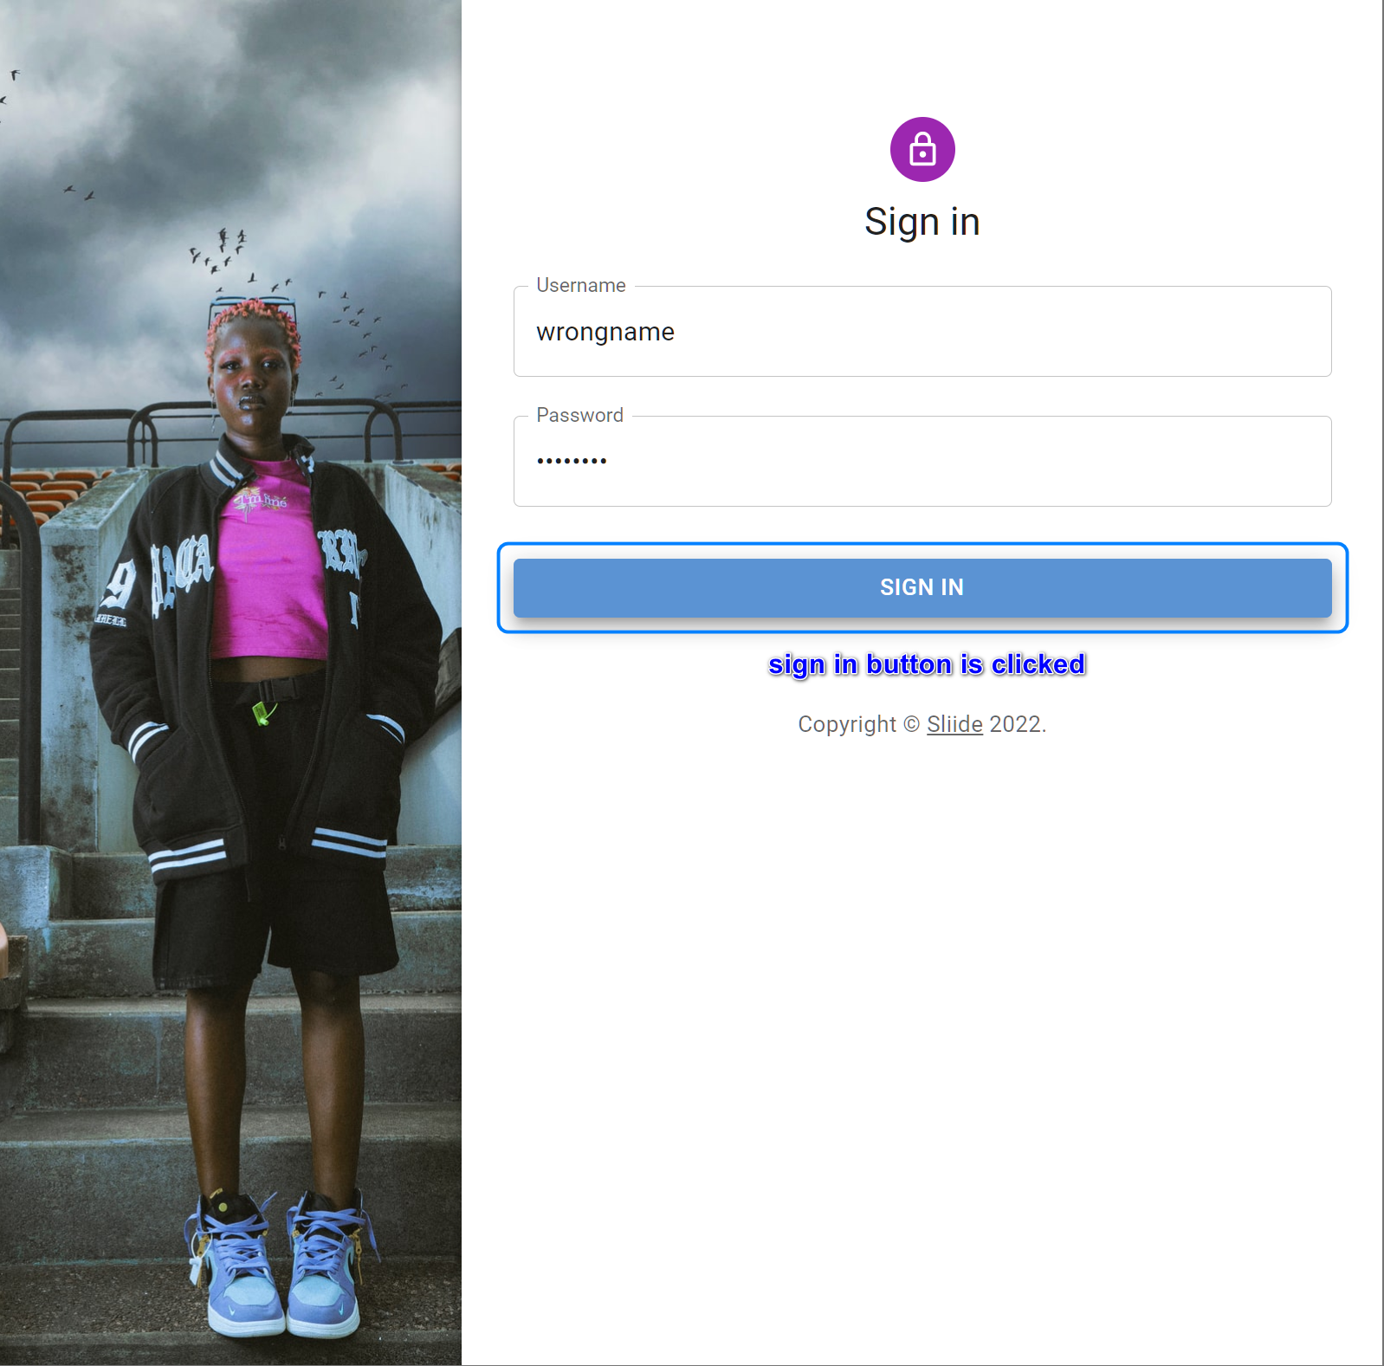

* + - * 1. **Then -** error markers are displayed by user name and/or password entries

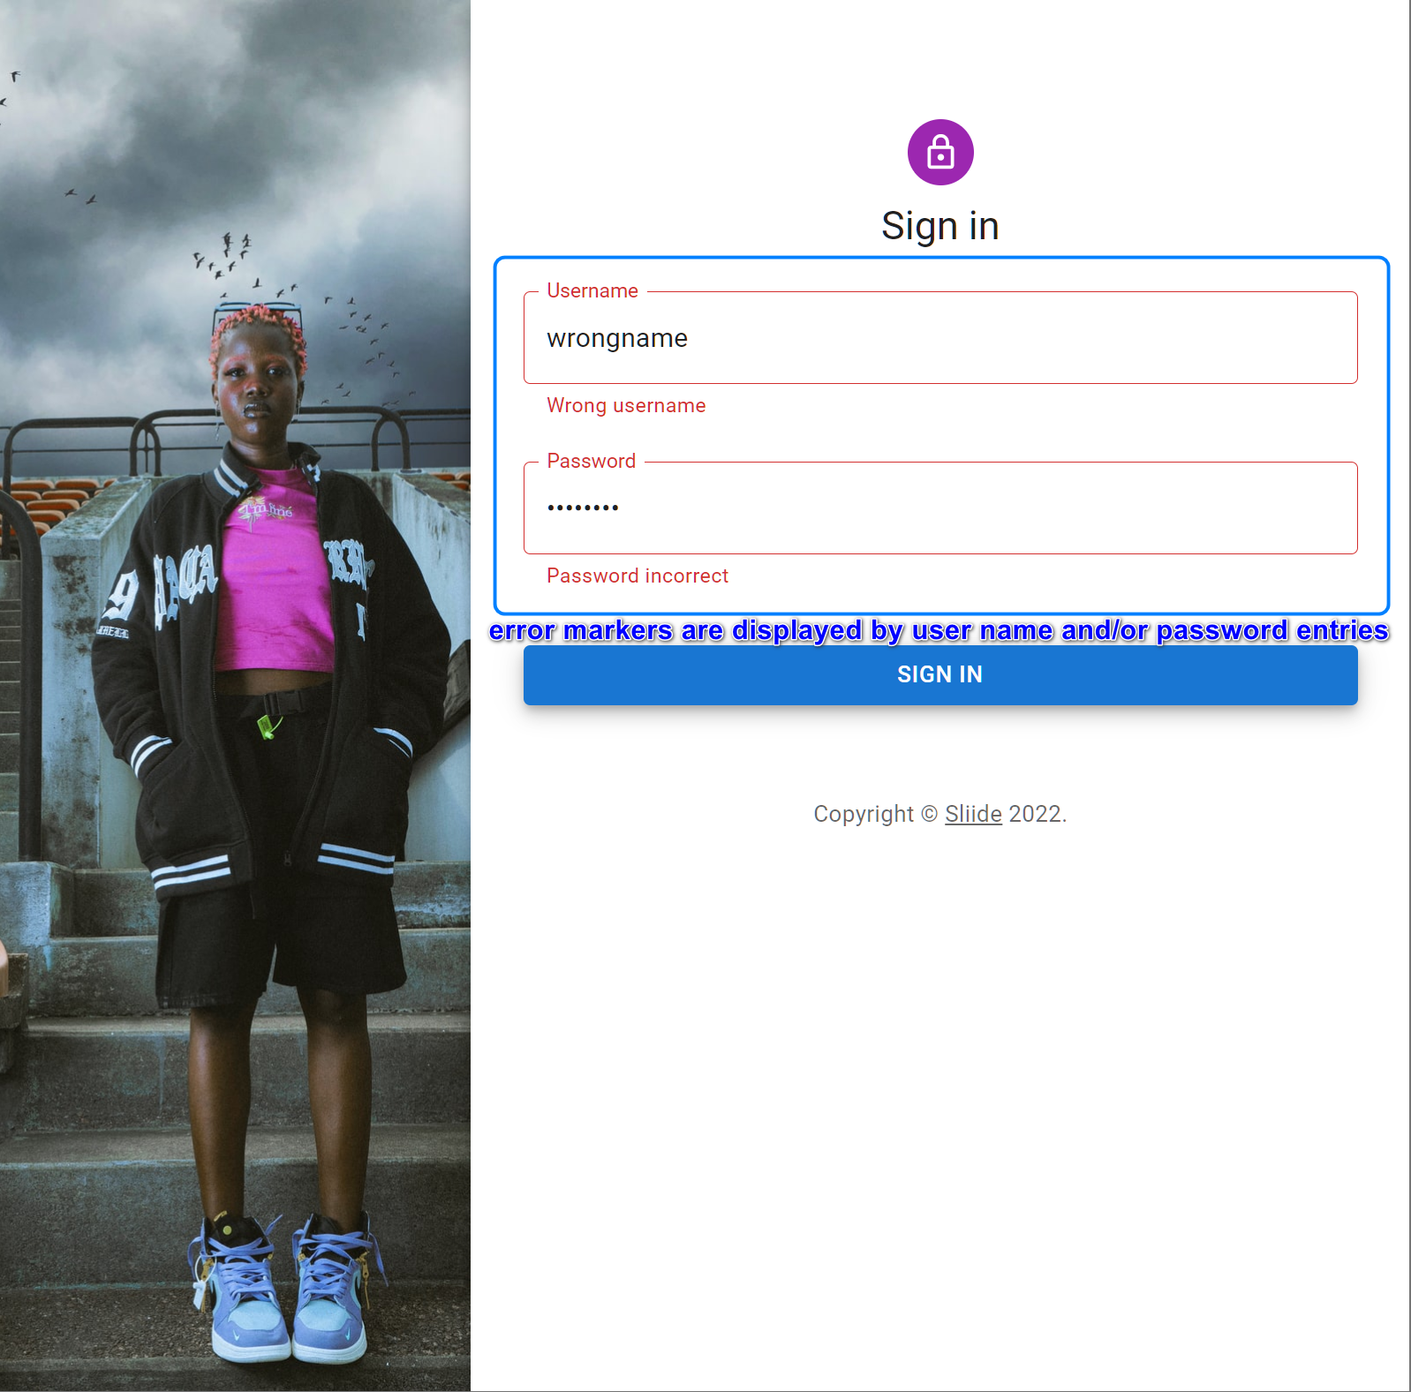

* + - 1. Scenario 3 – User login succeed (credentials provided below)
         1. **Given -** the user provided right user name and password

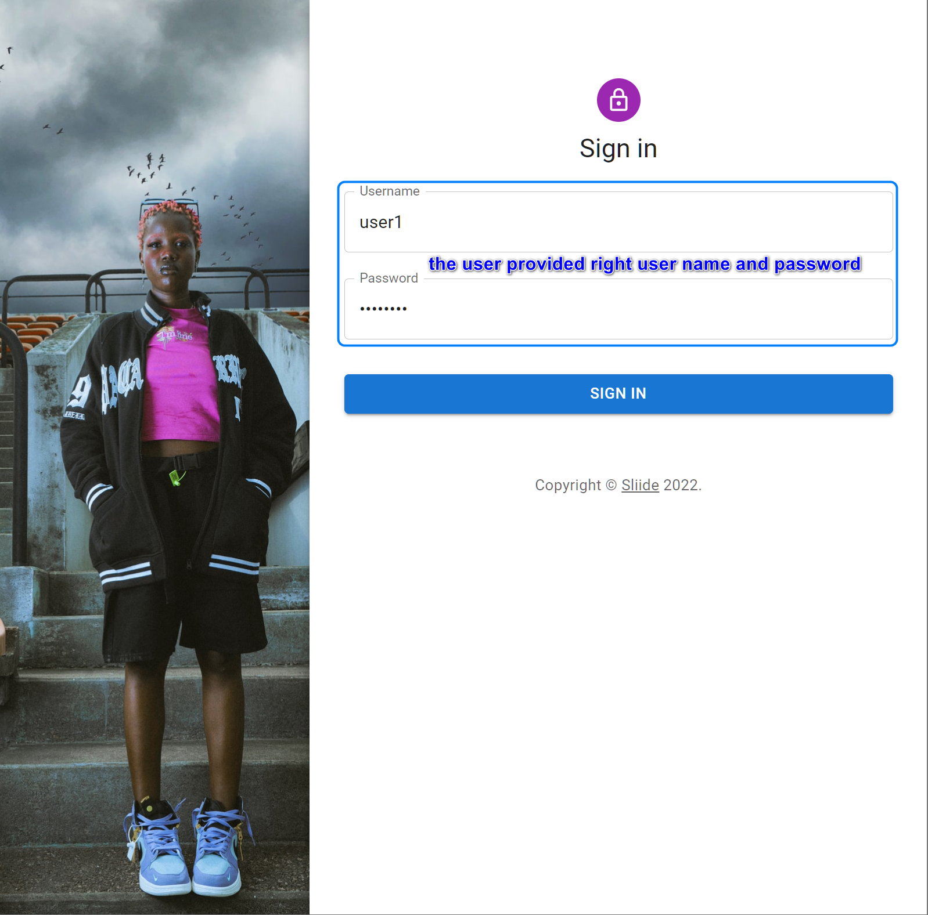

* + - * 1. **When -** sign in button is clicked

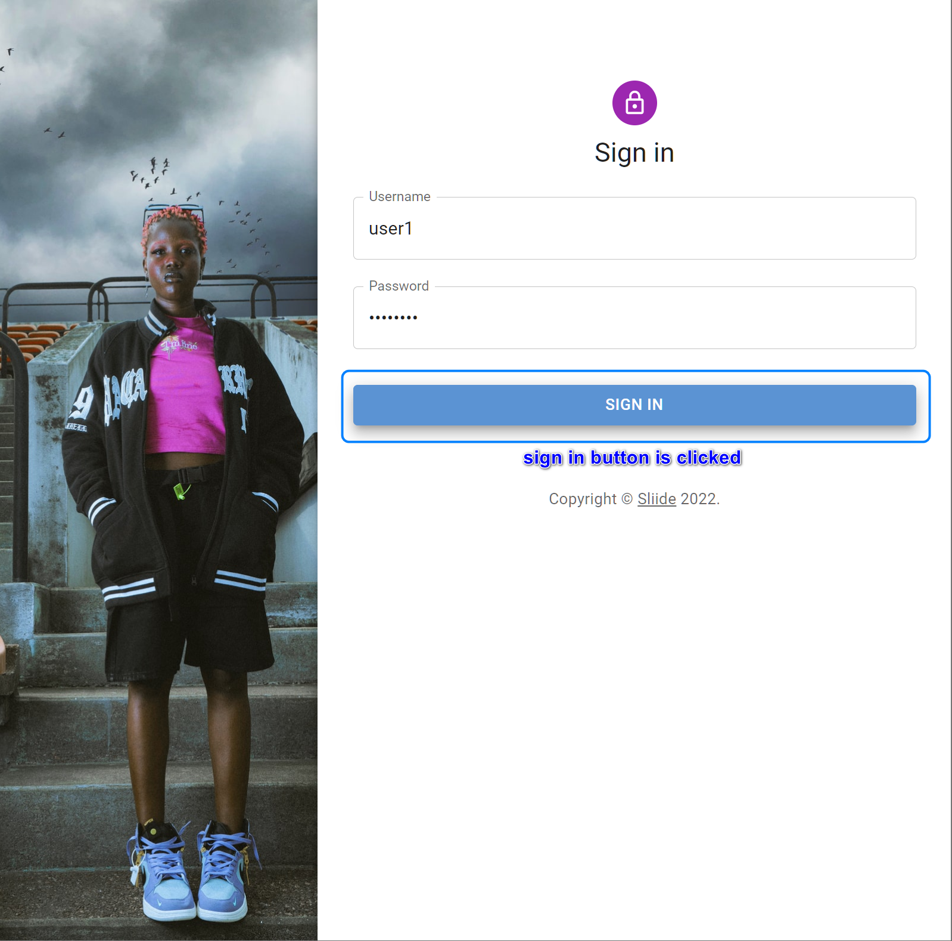

* + - * 1. **Then -** user is taken to the news page

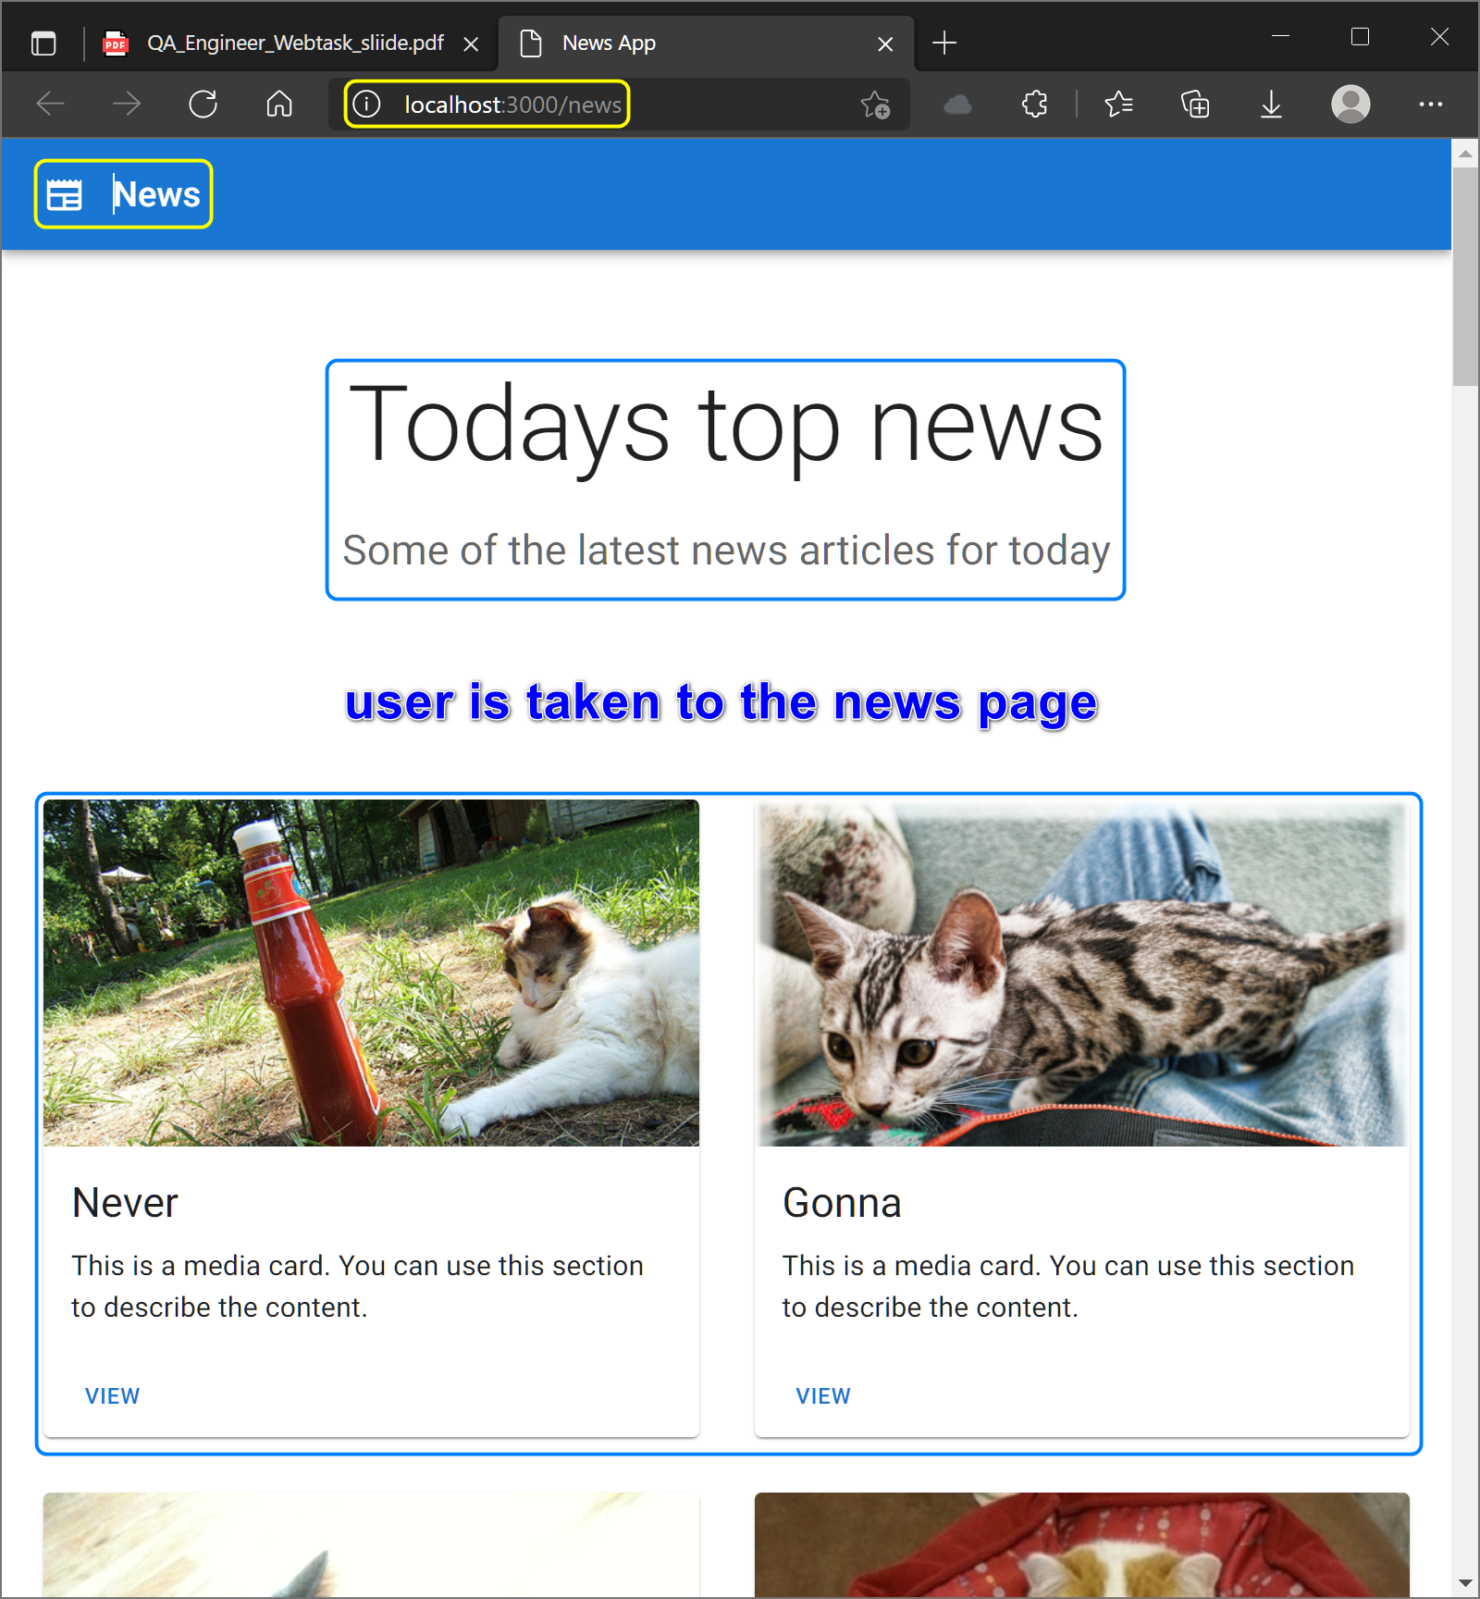

* + - 1. Scenario 4 – User opens web site next time (when previously logged in)

This site cannot store users’ cookies or tokens, so I have to log in every time.

* + - * 1. **Given -** the user opens web site next time (when previously logged in)

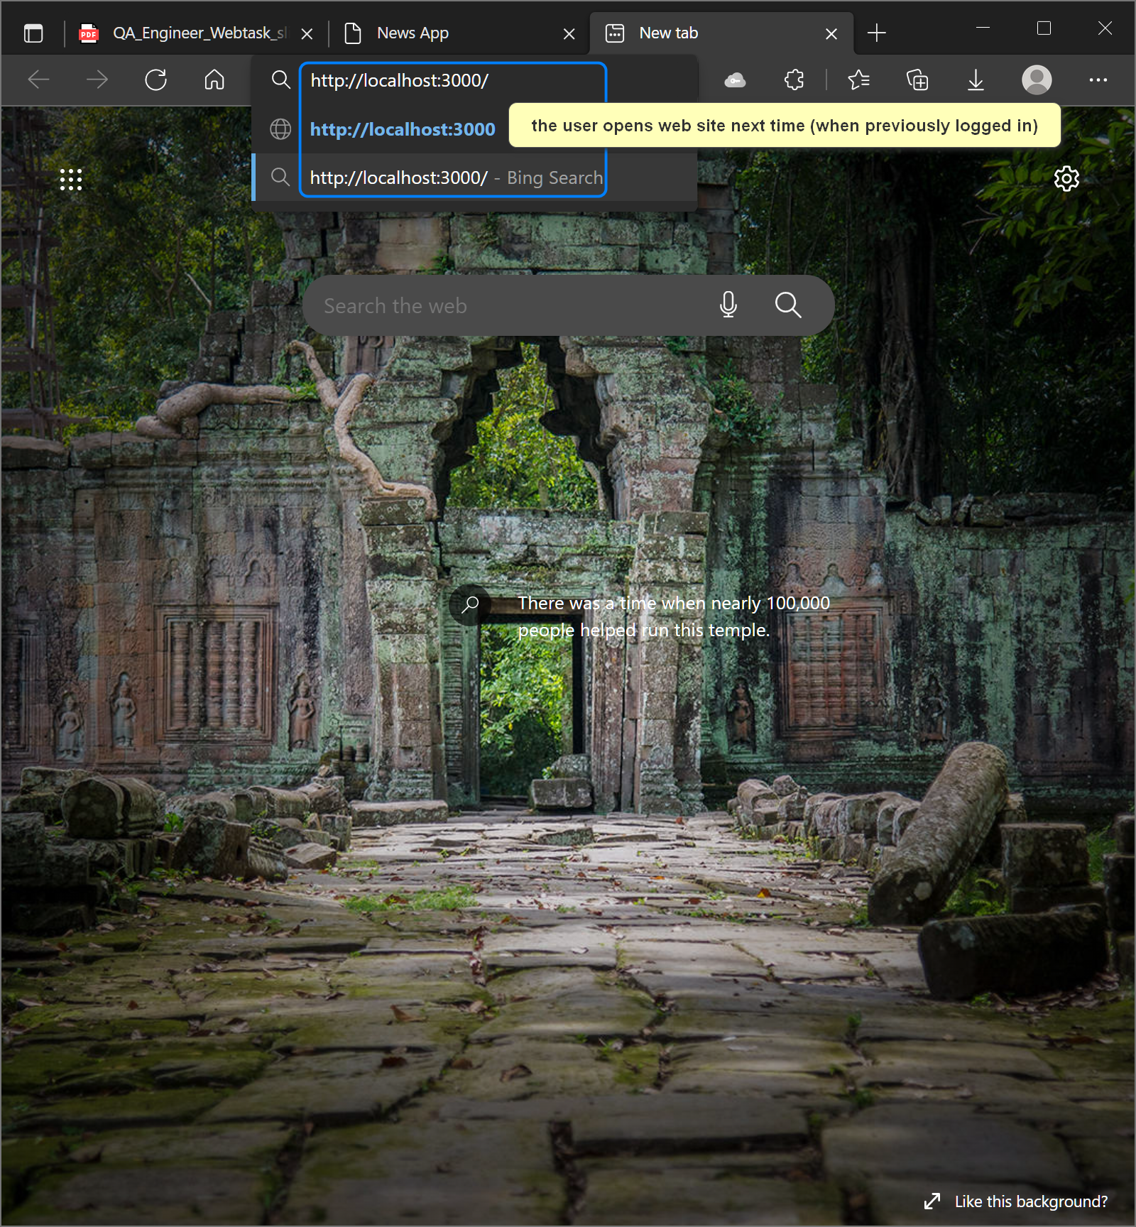

* + - * 1. **Then -** user is taken straight to the news screen

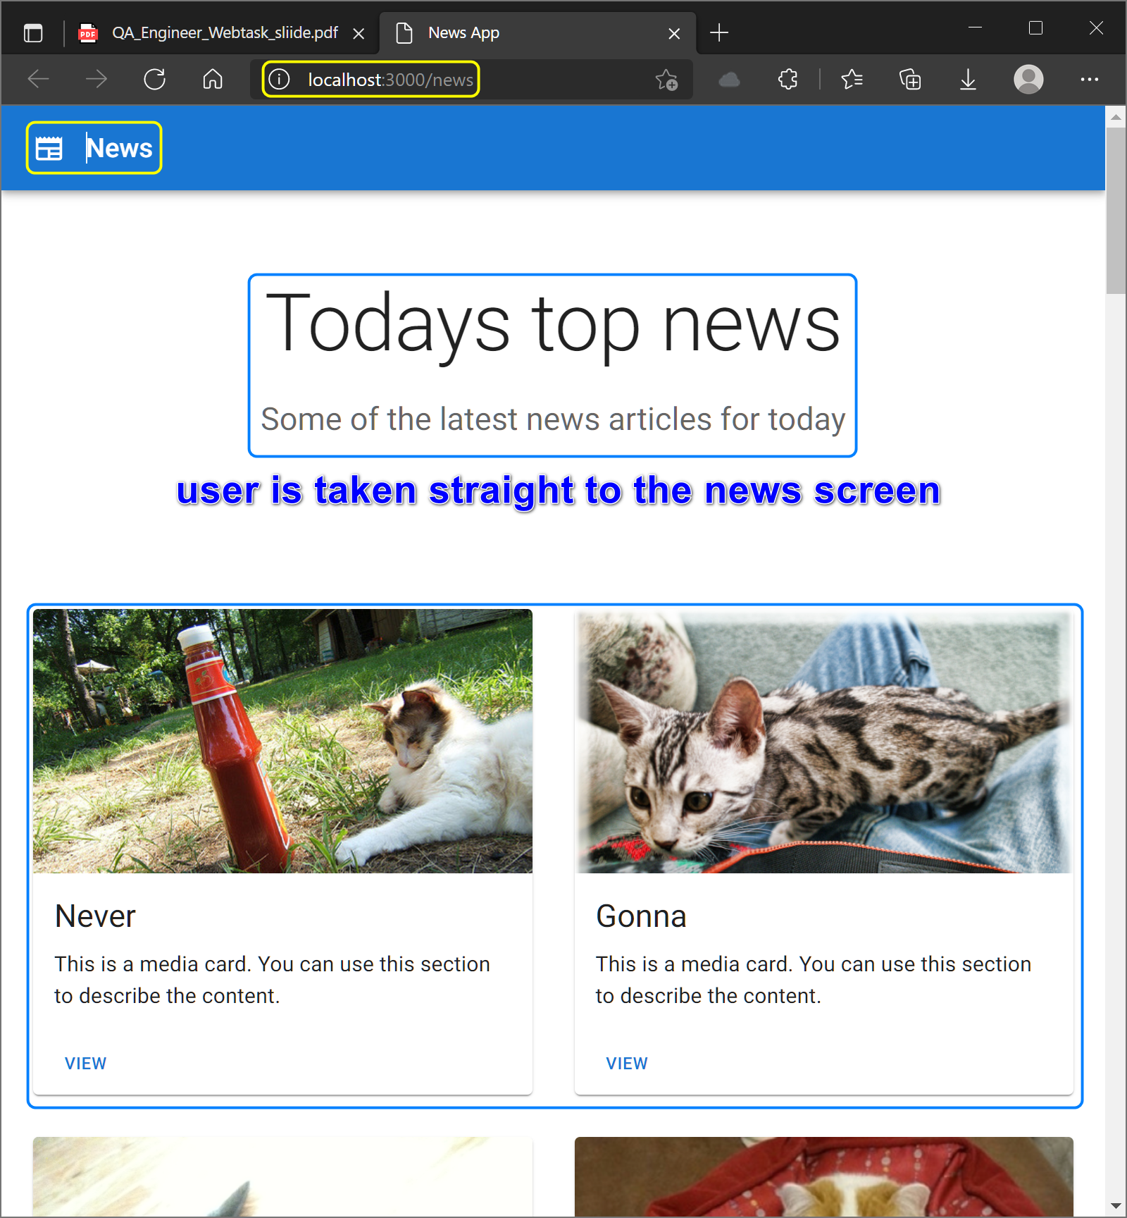

* + 1. Testing news page:
       1. Scenario 1 – News cards are loaded
          1. **Given -** there is internet connection
          2. **When -** the user successfully signs in to the app
          3. **Then -** news cards are displayed in rows and each card contains an image, text and a view button (cards can have one or more images scrollable horizontally)

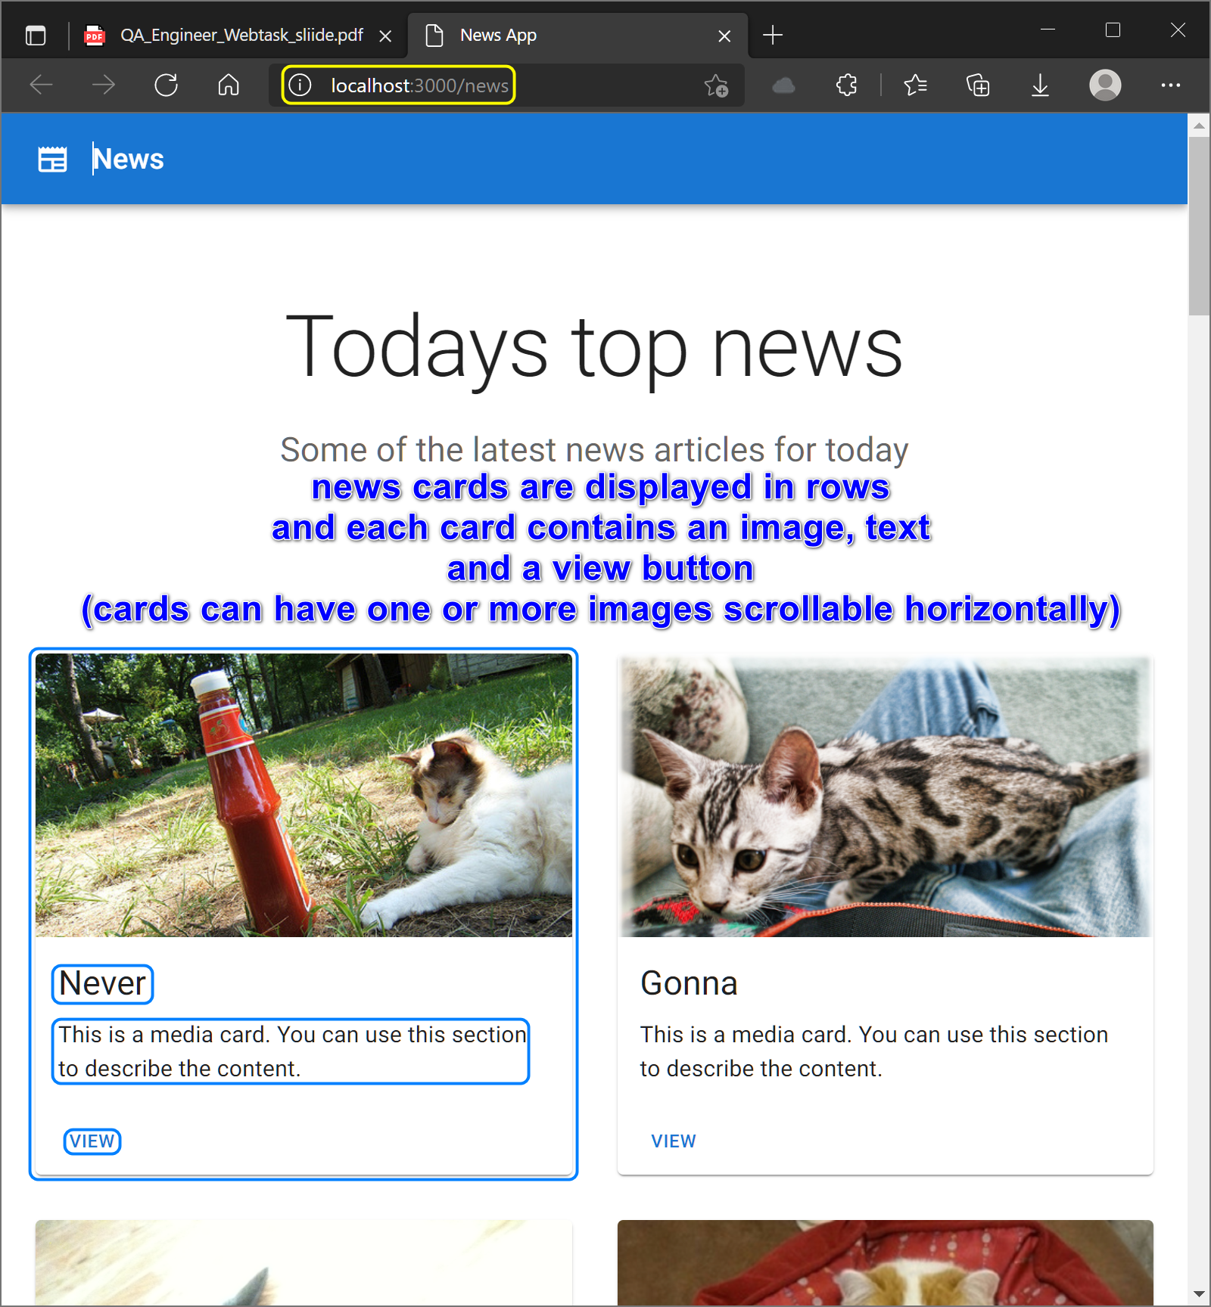

* + - 1. Scenario 2 – Failed to load news

There no Retry button is displayed.

* + - * 1. **Given -** there is no internet connection
        2. **When -** the user successfully signs in to the app
        3. **Then -** “failed to load news” error message and a Retry button are displayed

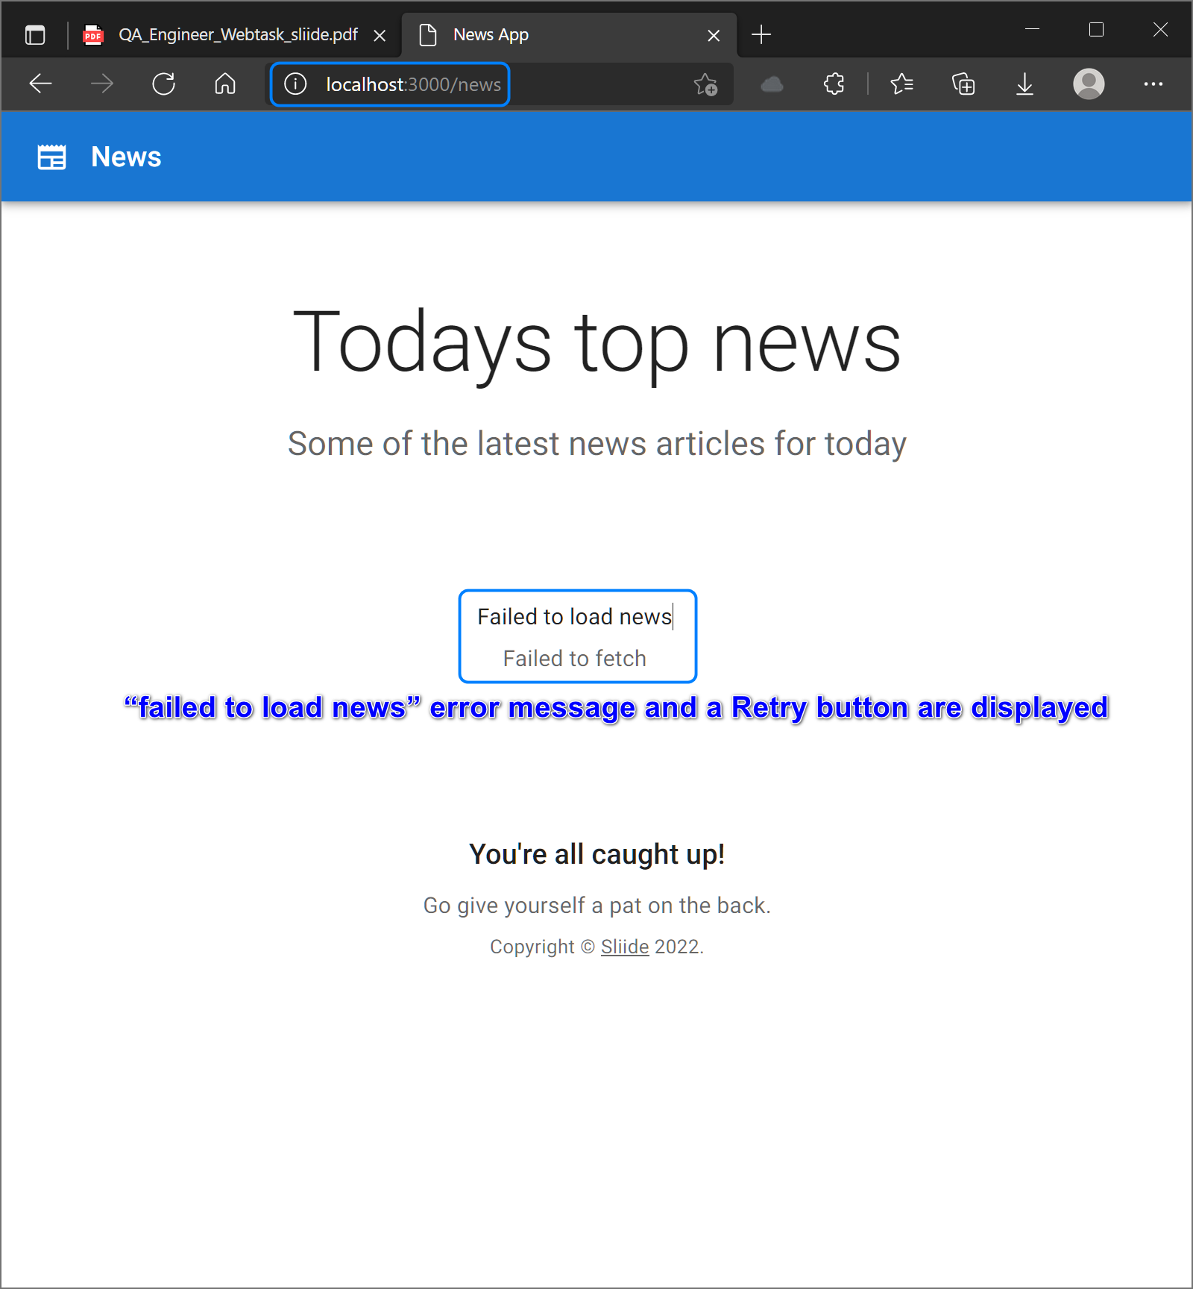

* + - 1. Scenario 3 – News view button is clicked
         1. **Given -** the news cards are successfully loaded on the screen

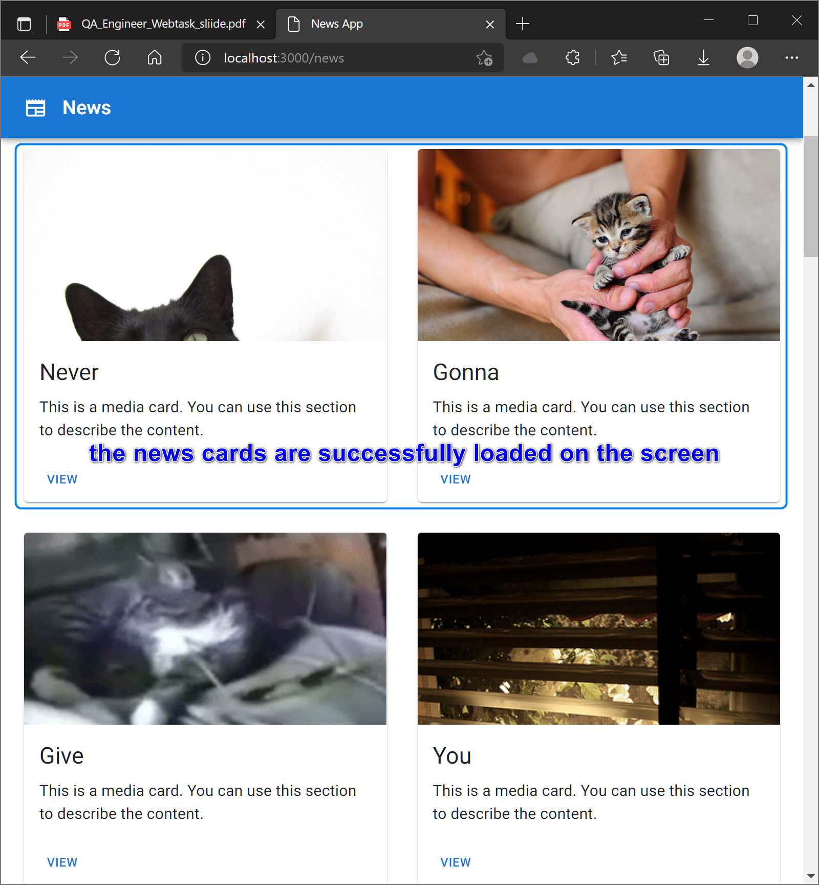

* + - * 1. **When -** the user clicks on the view button of the card

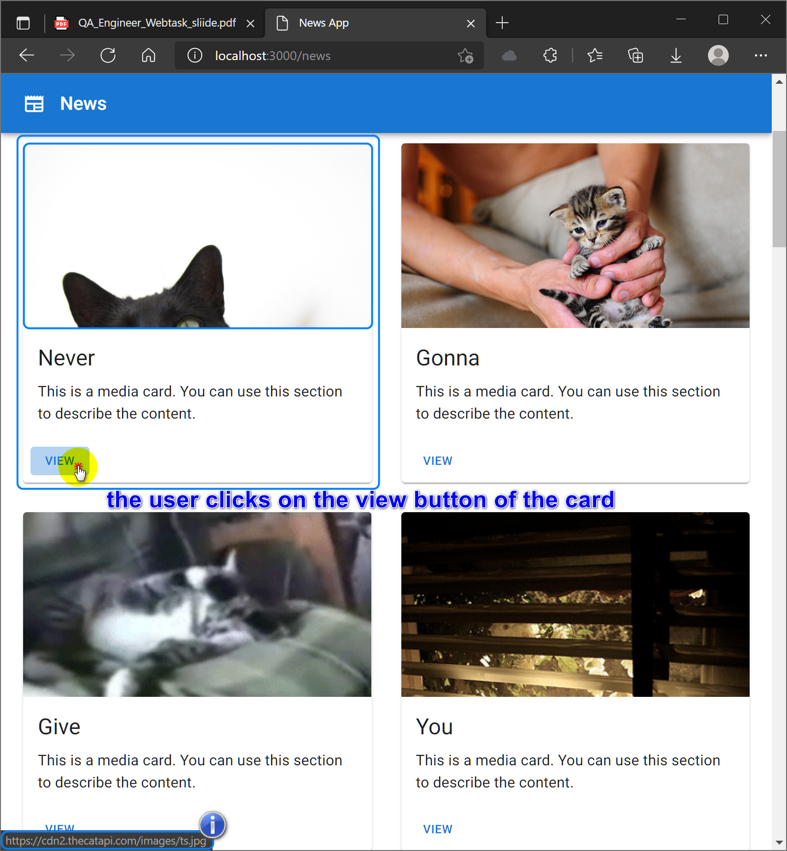

* + - * 1. **Then -** user is navigated to the image of the card

